1. [SELECT](http://localhost/phpmyadmin/url.php?url=https://dev.mysql.com/doc/refman/8.0/en/select.html) * FROM `obat` ORDER BY Stok_Barang DESC;

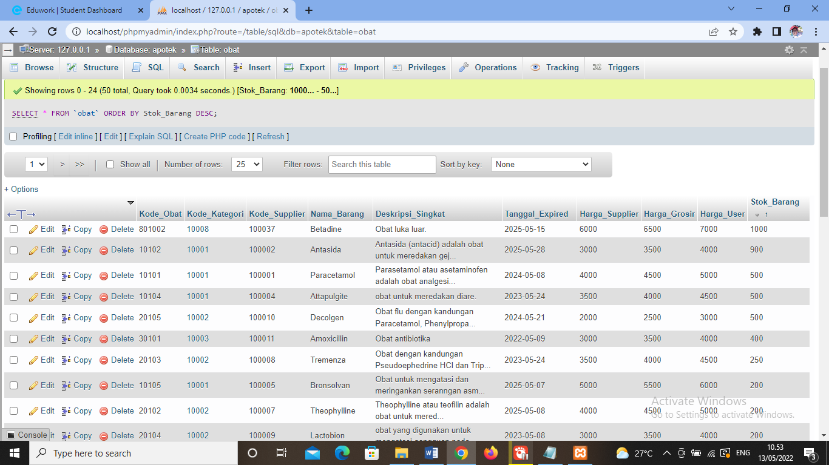

1. [SELECT](http://localhost/phpmyadmin/url.php?url=https://dev.mysql.com/doc/refman/8.0/en/select.html) * FROM `obat` ORDER BY Nama_Barang ASC;

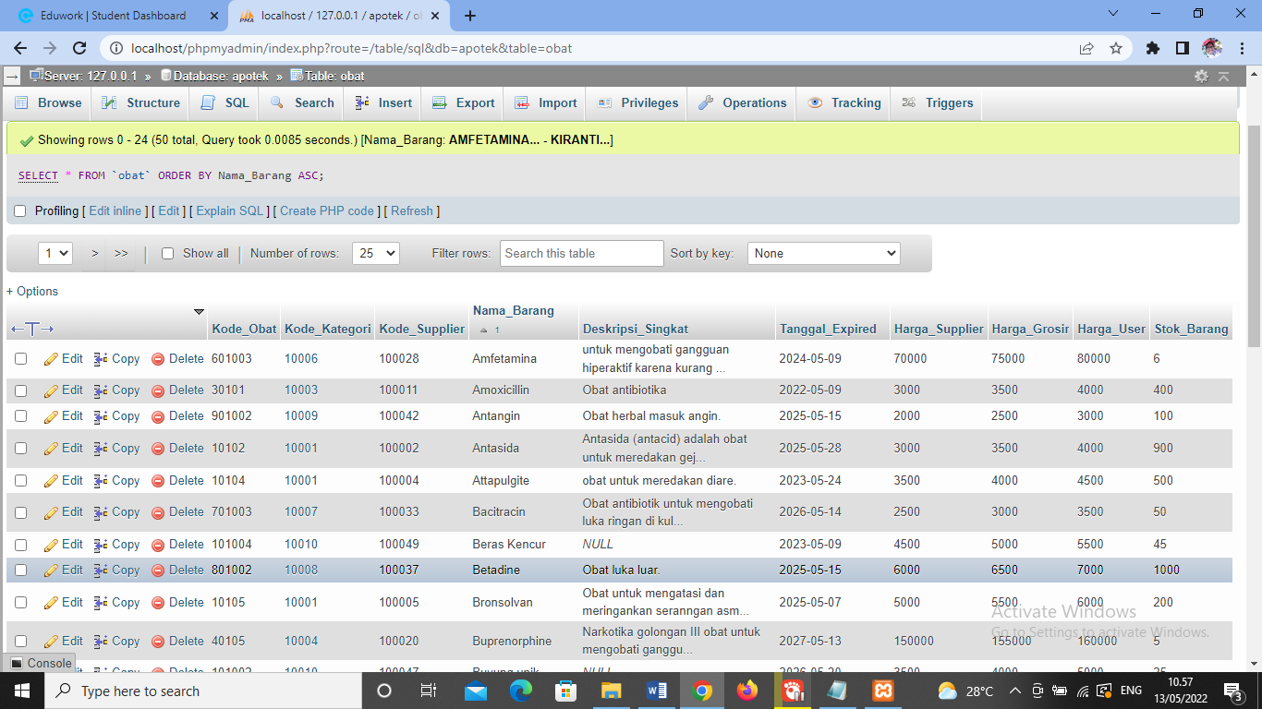

1. [SELECT](http://localhost/phpmyadmin/url.php?url=https://dev.mysql.com/doc/refman/8.0/en/select.html) * FROM `obat` WHERE Kode_Kategori [LIKE](http://localhost/phpmyadmin/url.php?url=https://dev.mysql.com/doc/refman/8.0/en/string-comparison-functions.html#operator_like) '%10001%';

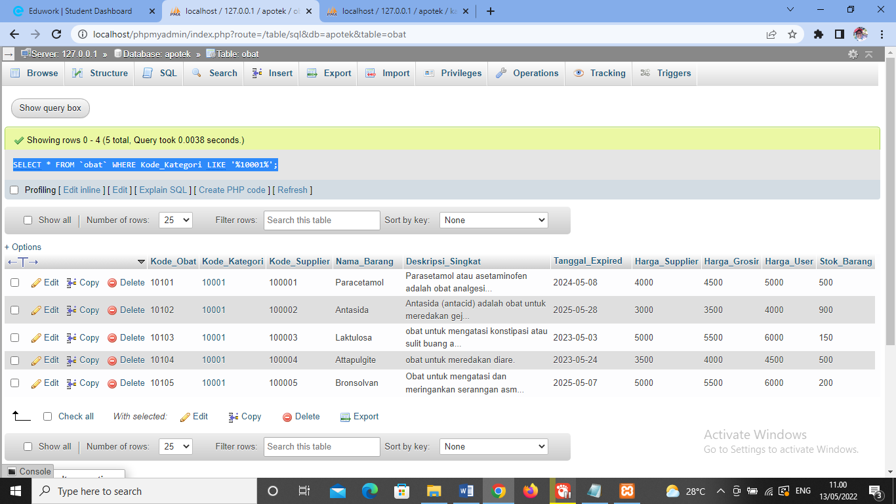

1. [SELECT](http://localhost/phpmyadmin/url.php?url=https://dev.mysql.com/doc/refman/8.0/en/select.html) * FROM `obat` WHERE Stok_Barang [LIKE](http://localhost/phpmyadmin/url.php?url=https://dev.mysql.com/doc/refman/8.0/en/string-comparison-functions.html#operator_like) '%500%';

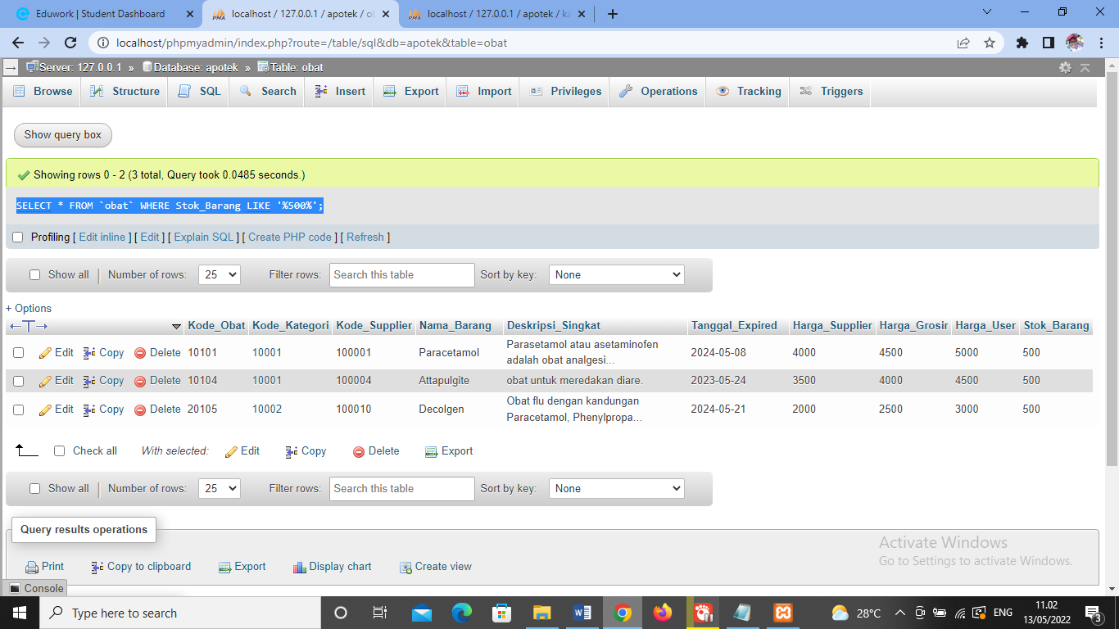

1. [SELECT](http://localhost/phpmyadmin/url.php?url=https://dev.mysql.com/doc/refman/8.0/en/select.html) Nama_Barang, [SUM](http://localhost/phpmyadmin/url.php?url=https://dev.mysql.com/doc/refman/8.0/en/group-by-functions.html#function_sum)(Stok_Barang) as total FROM `obat` GROUP BY Nama_Barang;

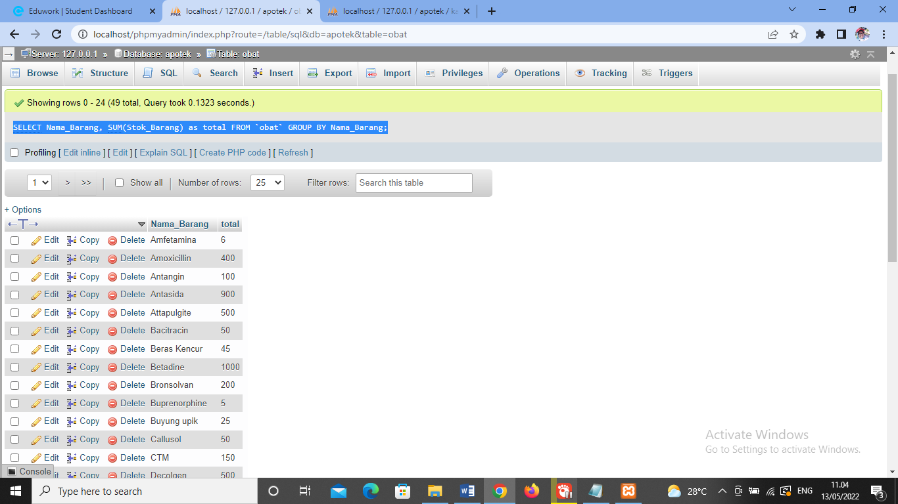

1. [SELECT](http://localhost/phpmyadmin/url.php?url=https://dev.mysql.com/doc/refman/8.0/en/select.html) Kode_Obat, [SUM](http://localhost/phpmyadmin/url.php?url=https://dev.mysql.com/doc/refman/8.0/en/group-by-functions.html#function_sum)(Stok_Barang) as total FROM `obat` GROUP BY Stok_Barang;

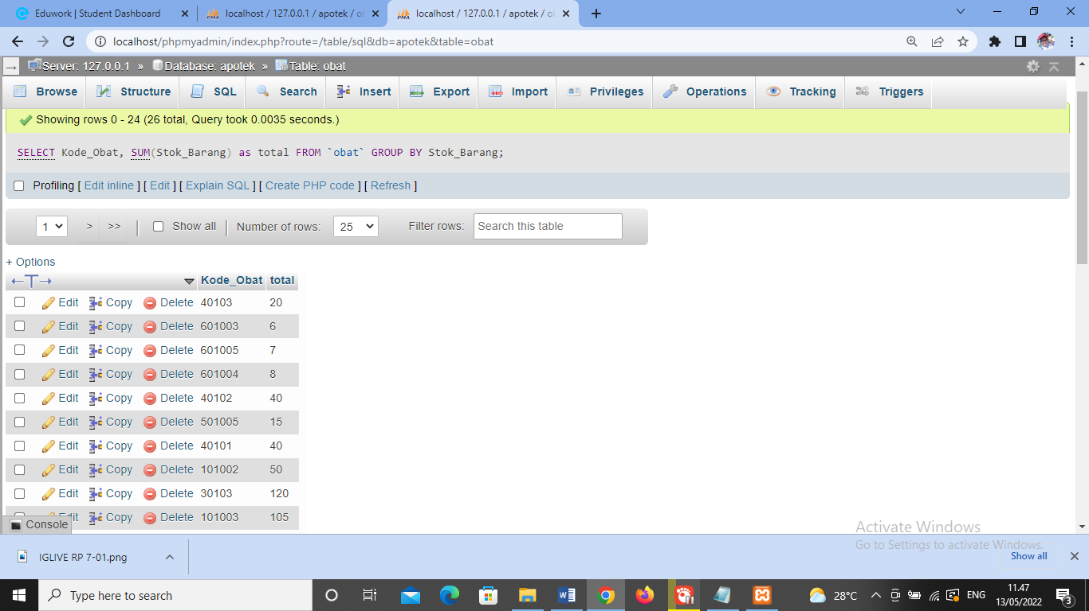

1. [SELECT](http://localhost/phpmyadmin/url.php?url=https://dev.mysql.com/doc/refman/8.0/en/select.html) Kode_Transaksi, [SUM](http://localhost/phpmyadmin/url.php?url=https://dev.mysql.com/doc/refman/8.0/en/group-by-functions.html#function_sum)(Jumlah_Pembelian) as total FROM `transaksi` GROUP BY Jumlah_Pembelian;

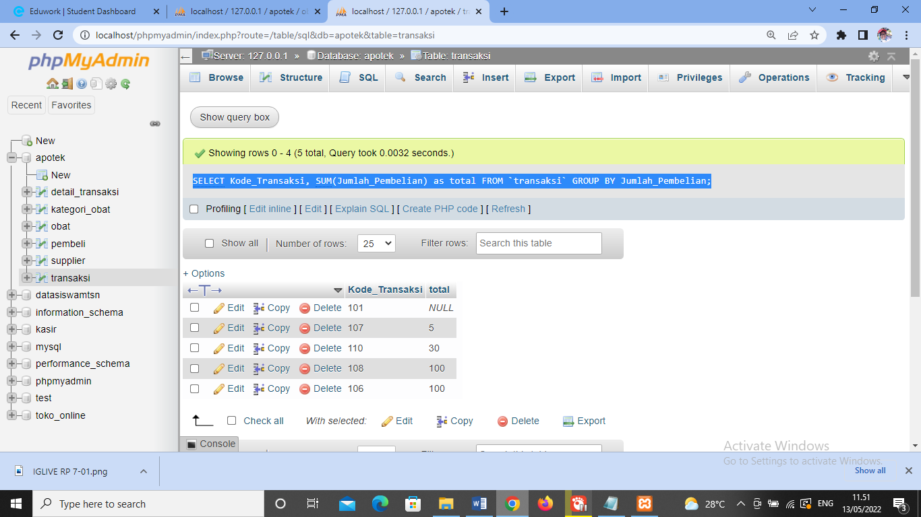

1. [SELECT](http://localhost/phpmyadmin/url.php?url=https://dev.mysql.com/doc/refman/8.0/en/select.html) Kode_Obat, [SUM](http://localhost/phpmyadmin/url.php?url=https://dev.mysql.com/doc/refman/8.0/en/group-by-functions.html#function_sum)(Jumlah_Penjualan) as total FROM `transaksi` GROUP BY Kode_Obat;

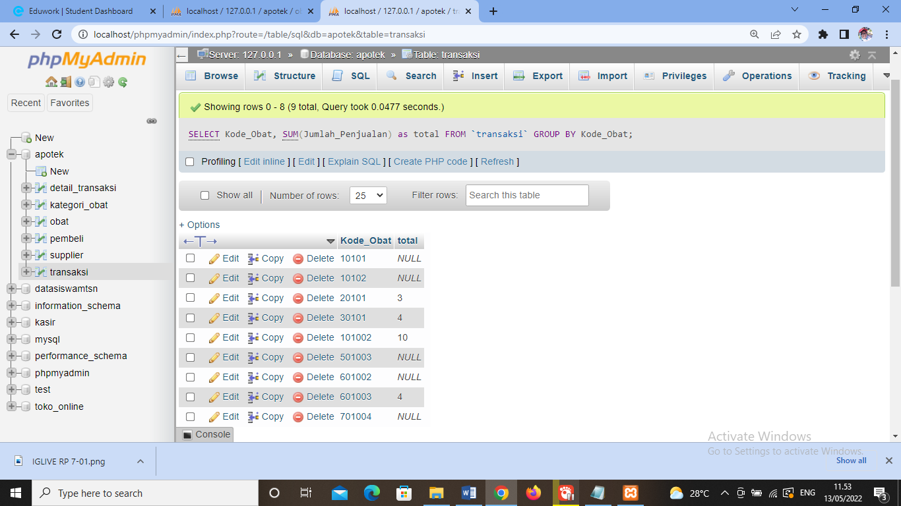

1. [SELECT](http://localhost/phpmyadmin/url.php?url=https://dev.mysql.com/doc/refman/8.0/en/select.html) Tanggal_Expired, [SUM](http://localhost/phpmyadmin/url.php?url=https://dev.mysql.com/doc/refman/8.0/en/group-by-functions.html#function_sum)(Stok_Barang) as total FROM `obat` WHERE Tanggal_Expired >=2023-05-24 GROUP BY Tanggal_Expired ORDER BY Tanggal_Expired DESC;

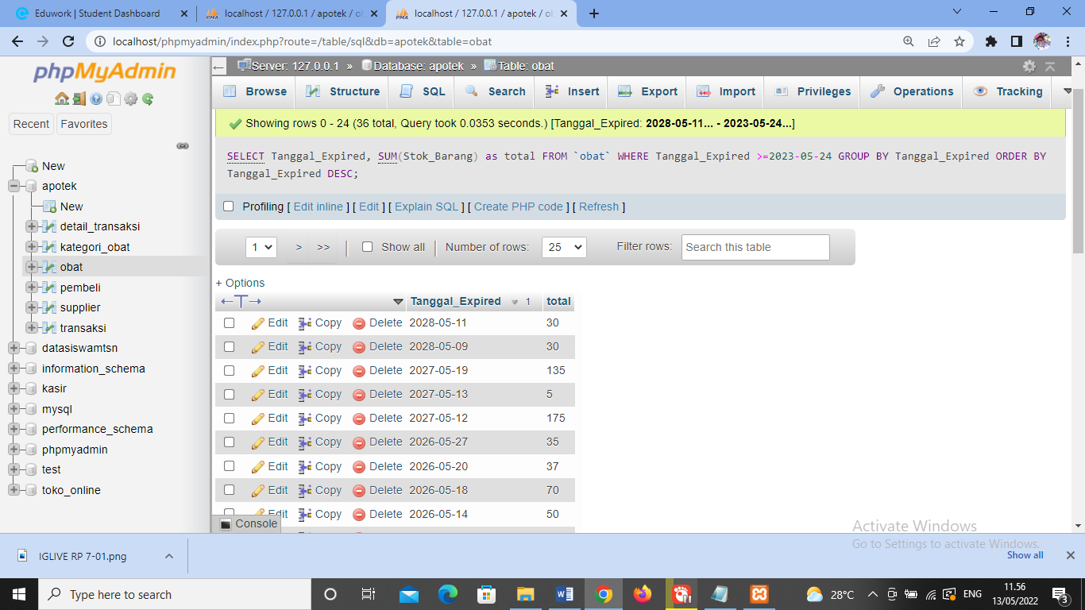

1. [SELECT](http://localhost/phpmyadmin/url.php?url=https://dev.mysql.com/doc/refman/8.0/en/select.html) Tanggal_Transaksi, [SUM](http://localhost/phpmyadmin/url.php?url=https://dev.mysql.com/doc/refman/8.0/en/group-by-functions.html#function_sum)(Jumlah_Pembelian) as total FROM `transaksi` GROUP BY Tanggal_Transaksi ORDER BY Tanggal_Transaksi ASC;

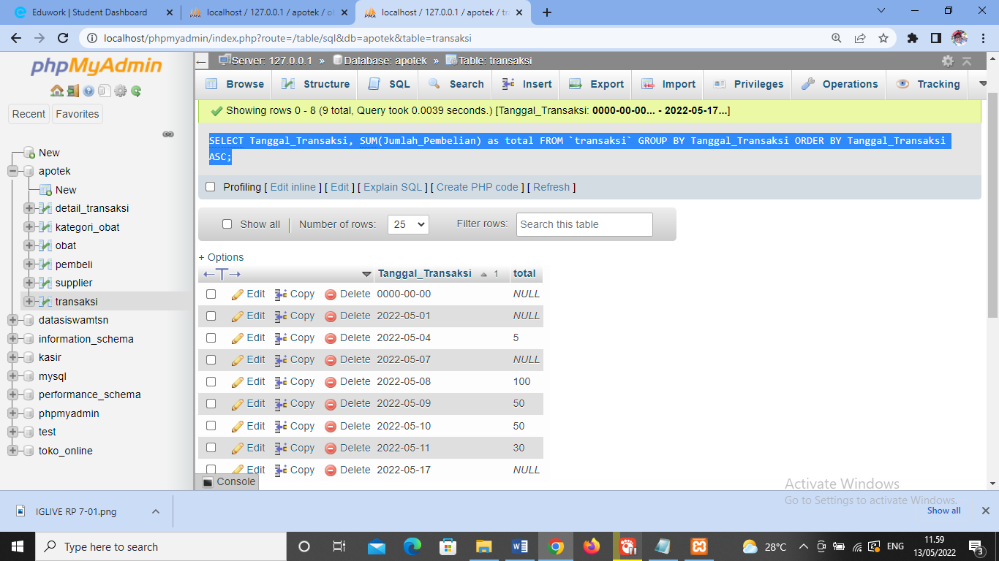

1. [SELECT](http://localhost/phpmyadmin/url.php?url=https://dev.mysql.com/doc/refman/8.0/en/select.html) Tanggal_Transaksi, [SUM](http://localhost/phpmyadmin/url.php?url=https://dev.mysql.com/doc/refman/8.0/en/group-by-functions.html#function_sum)(Jumlah_Penjualan) as total FROM `transaksi` GROUP BY Tanggal_Transaksi ORDER BY Tanggal_Transaksi DESC;

